
ANALELE universităŢii

“eftimie murgu” reşiţa
Anul XVIII, Nr. 1, 2011, ISSN 1453 - 7394

Please insert here the name(s) of the author(s) in format of First Names and SurName of the Authors (without titles and addresses). This paragraph was created with style “Authors”. Example:
Constantin Viorel Câmpian, Nicoleta Gillich (Tahoma, 10, Normal)
Please insert here the title of the paper use capital letters where needed. This paragraph was created with style "Title of the paper".
Example:
The Results form Index Tests Performed on the Kaplan Turbines (Tahoma, 12, Bold)
Please insert here the text of abstract (without word Abstract) Text of the abstract no more than 12 lines, but minimum 5 lines. This paragraph was created with style Tahoma, 10, Italic (see Format / Paragraf). Abstract and titles are indented from both sides with 0,9 cm.
Keywords: insert, 3 up to 5, keywords
Please insert here the title of section numbered or not This paragraph was created with style "Section". Example:
1. Introduction (unnumbered sections also allowed) Tahoma, 10, Bold (see Format/Pargraf)
Paper margins: Top & Bottom 5.5 cm, Left & Right 4 cm, Paper Size A4, minimum 4 pages and maxim 12 pages with odd number of pages.
Tabulatori 0,7. Text of the section. (Tahoma, 10, Normal)Text of the section. Text of the section. Text of the section. Text of the section. Text of the section.
Please use Equation Editor for equations. Example given below
The equation is part of the text so it must have normal text ending - comma or full-stop, like
$\frac{V_{p}}{V_{m}}=\frac{\sqrt{ρ_{m}⋅δ_{p}}}{\sqrt{ρ_{p}⋅δ_{m}}}$, (1)
just as shown above.
Text of the section. Text of the section. Text of the section. Text of the section. Text of the section. Text of the section. (Tahoma, 10, Normal)
This is an example of figure import. In order to get figures best printed, please make them ready in 600 dpi before importing it into MS-Word.
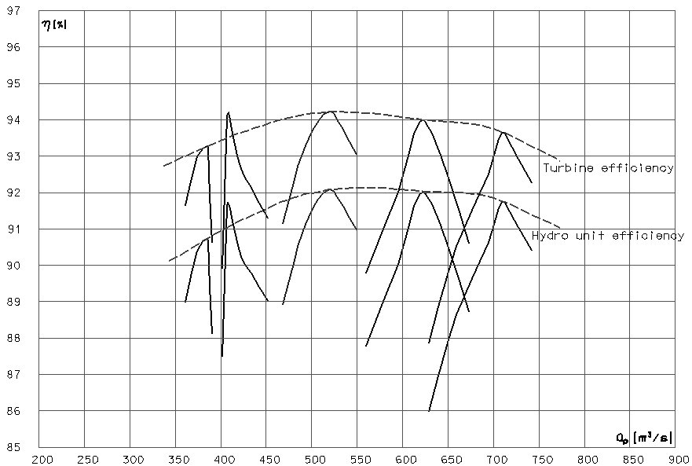

(Tahoma, 10, Bold) Figure 1. The text of figure caption. (Tahoma, 10, Normal)

Text of the section. Text of the section. Text of the section. Text of the section.. To create text of the section use style "Body". (Tahoma, 10, Normal)
Textwidth is set to 13 cm and textheight to 19 cm.

2. Analysis. Title of the second section may be longer than one row but just leave it like this. (Tahoma, 10, Bold)
Text of the section. Text of the section. Text of the section. Text of the section. Text of the section. Text of the section. Text of the section. (Tahoma, 10, Normal)

3. Examples. Title of the second section may be longer than one row but just leave it like this. The paper can include all the necessary sections. (Tahoma, 10, Bold)
Text of the section. Text of the section. Text of the section. Text of the section. Text of the section. Text of the section. Text of the section. (Tahoma, 10, Normal)

(Tahoma, 10, Bold) Table 1.
Text | Text | Text | Text | Text
(Tahoma, 10, Normal)

Text of the section. Text of the section. Text of the section. Text of the section.
4. Conclusion (Tahoma, 10, Bold) before and after 17 pct
Text of the section. Text of the section. Text of the section. Text of the section. Text of the section. Text of the section. Text of the section. (Tahoma, 10, Normal)
References (Tahoma, 10, Bold) before and after 17 pct
Please insert here the references according to the example below. All references must be find in the paper.
- ***** Field acceptance tests to determine the hydraulic performance of hydraulic turbines, storage pumps and bulb turbines. International Standard IEC 41/1991-11.
- Campian C.V., Zsembinszki S., Hydrodinamic turbines discharge measurement by Winter-Kennedy method. Proceedings “Conferinta Nationala de Energetica”, Neptun, 19 – 18 iunie 1992, Romania, 133-142.
- These paragraphs were created with left 0,55 cm and right 0,9 cm., with numbering turned on by default. (Tahoma, 10, Normal+Italic- only Paper title)
Addresses:-this paragraph was created with style "Section" italic added and bold turned off. Space before and after 17pt. (Tahoma, 10, Italic)
Please insert here the addresses according to the example below.
- Prof. Dr. Eng. Constantin Viorel Câmpian, “Eftimie Murgu” University of Reşiţa, Piaţa Traian Vuia, nr. 1-4, 320085, Reşiţa, v.campianu@uem.ro
- Prof. Dr. Eng. Nicoleta Gillich, “Eftimie Murgu” University of Reşiţa, Piaţa Traian Vuia, nr. 1-4, 320085, Reşiţa, n.gillich@uem.ro
- These paragraphs were created with style "Address", bullets turned on by default. (Tahoma, 10, Normal) left 0,3 cm, right 0,9 cm

